**MESD LMS Documentation - View/print Results Analysis for her/his classes**

**Purpose**

Allow senior educators to view and print results analysis for their classes. The following capabilities were added to facilitate this:

* report/performance:view

**Usage**

1. Log in as a **Senior Educator.**
2. Navigate to a course, go to course administration and click on **Grades**.

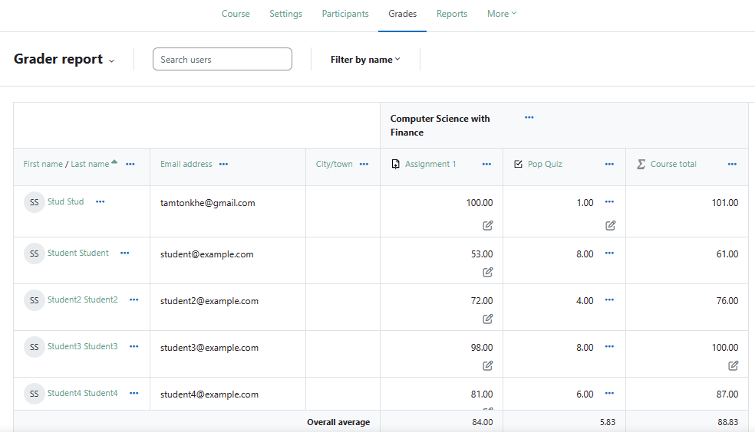

Results for every graded assessment will be displayed here along with the class average for each assessment and average for course total.

1. Click on the **Grader report** dropdown menu and click on **Grade summary** to view the grade summary of the entire class.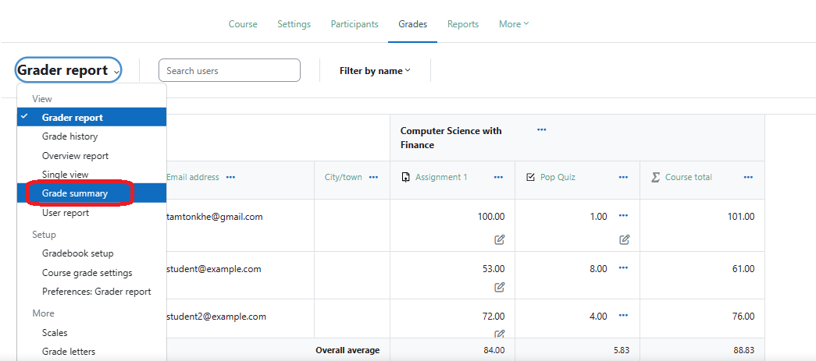

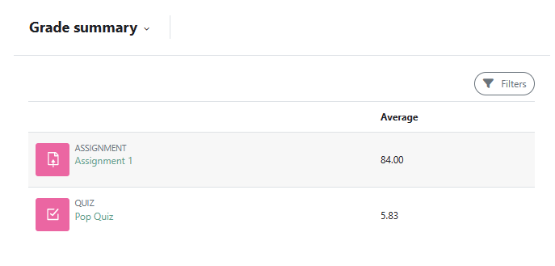

1. To download table data click on the dropdown menu and scroll to **Export** under **View**.

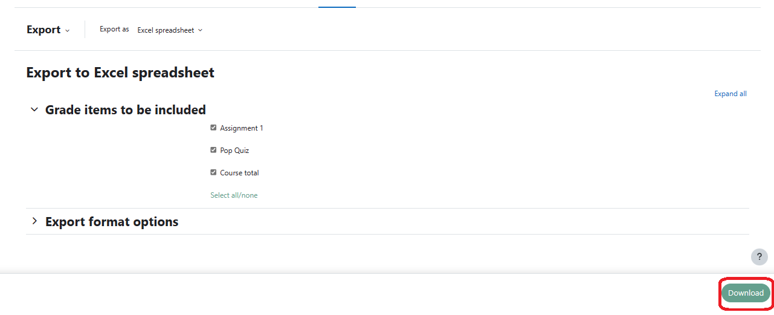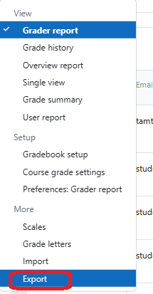

Select the file format, select the assignment results and course totals you’d like to download and click **Download** to get the data.

1. Activities like quizzes can express results visually as well. To view them go to the quiz in question, from the administration menu click **Results**.

